# PROJECT REPORT

## 1.INTRODUCTION

### 1.1 OVERVIEW

### Creating a Sponsored Instagram post on the fashion brand Stylez.The Sponsored Instagram Post Project for Stylez aimed to harness the power of Instagram for marketing and brand promotion. The project focused on influencer partnerships, content creation, and strategic posting to achieve specific objectives.

### 1.2 PURPOSE

The purpose of a project involving sponsored Instagram posts for Stylez can encompass,

Brand Awareness and Visibility: One of the primary purposes is to increase brand recognition and exposure. By utilizing sponsored Instagram posts, Stylez can reach a larger and more diverse audience than with organic content alone.

Audience Engagement: Sponsored posts can facilitate engagement with the existing and potential customer base. They provide a means for followers to interact with the brand, ask questions, and share their opinions.

Sales and Conversions: A key purpose may be to boost sales and conversions. Sponsored posts can serve as a direct sales channel, encouraging users to explore products and make purchases through call-to-action buttons and links.

Influencer Collaborations: Collaborating with influencers can be a purpose in itself, aiming to leverage the influencer's reach and credibility to introduce Stylez to their followers.

Reinforcing Brand Image: Sponsored posts can be used to establish and strengthen the brand's identity and reputation. By curating content that aligns with Stylez's values and aesthetics, the project can reinforce a particular image in the minds of the audience.

Market Research: Sponsored posts can serve as a way to gather valuable data about the target audience. The interactions, comments, and feedback on these posts can provide insights into customer preferences and market trends.

## 2.OBJECTIVES

The primary objectives of the project were as follows:

Amplify Brand Visibility: Expand Stylez's presence on Instagram and reach a broader audience within the fashion and lifestyle niches.

Drive Engagement: Foster meaningful connections with the Instagram community, increasing likes, comments, and shares on sponsored posts.

Increase Sales and Conversions: Encourage users to explore the brand's offerings and convert engagement into sales.

Build Brand Credibility: Establish Stylez as a reputable and trendsetting brand in the fashion industry.

## 3.PROBLEM DEFINITION AND DESIGN THINKING

### 3.1 EMPATHY MAP

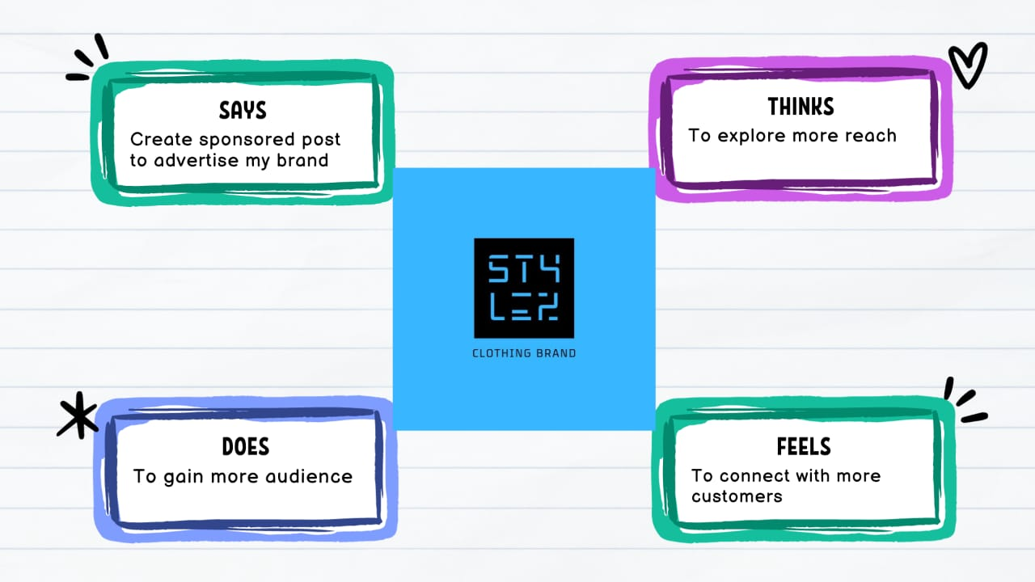

### 3.2 BRAINSTORMING MAP

### 4.RESULTS

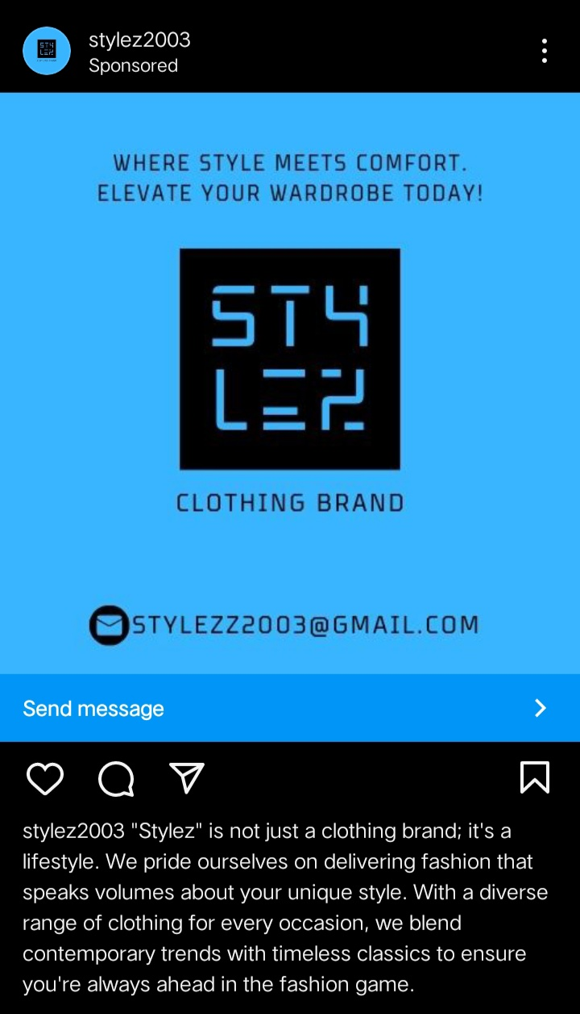

### OUTCOMES

The project yielded significant positive outcomes:

Follower Growth: A substantial increase in the follower count, expanding Stylez's reach and appeal.

Engagement: Consistent likes, comments, and shares on sponsored posts, creating a vibrant community and interaction among followers.

Conversion Rate: An observable increase in website traffic and sales, demonstrating the efficacy of sponsored content in driving conversions.

Brand Credibility: The brand solidified its reputation as a trendy and credible fashion brand, thanks to influencer collaborations.

### ADVANTAGES

Advantages of a project involving sponsored Instagram posts for Stylez include:

Expanded Reach: Sponsored posts allow Stylez to reach a broader and more diverse audience, increasing brand exposure and awareness.

Audience Targeting: Stylez can specifically target its ideal audience, ensuring that its content reaches those most likely to engage with the brand and make purchases.

Increased Engagement: Sponsored posts can foster higher engagement levels, including likes, comments, and shares, creating a more active and loyal community of followers.

Influencer Collaboration: Partnering with influencers can lend credibility to the brand and introduce it to new and engaged audiences.

Direct Sales Channel: Sponsored posts can include links and call-to-action buttons, making it easier for users to explore and purchase Stylez's products directly.

Enhanced Analytics: Instagram's business tools provide valuable insights into the performance of sponsored posts, allowing for data-driven decision-making and optimization.

Competitive Advantage: Consistent and engaging sponsored posts can keep Stylez competitive in the fashion industry and ensure that it remains top-of-mind for its target audience.

Creative Freedom: Sponsored posts offer creative freedom, enabling Stylez to experiment with various content formats and styles to capture the attention of its audience.

Market Research: Interactions and comments on sponsored posts provide insights into customer preferences and market trends, informing product development and marketing strategies.

### 

### DISADVANTAGES

Certainly, there are also some potential disadvantages to consider in a project involving sponsored Instagram posts for Stylez:

Cost: Sponsored posts can be expensive, particularly if Stylez collaborates with well-known influencers. The budget for these posts may be significant.

Saturation: The Instagram platform can be saturated with sponsored content, making it challenging to stand out and capture the audience's attention.

Ad Fatigue: Overexposure to sponsored posts can lead to audience fatigue and reduced engagement, especially if followers feel overwhelmed by promotional content.

Authenticity Concerns: Some users may view sponsored posts as less authentic or trustworthy compared to organic content, potentially affecting brand credibility.

Influencer Reliability: Relying on influencers for sponsored posts can be risky if they engage in behavior that could harm the brand's reputation.

Content Quality: The quality and effectiveness of sponsored content can vary, and poorly executed posts may not yield the desired results.

Changing Algorithms: Instagram's algorithms can change, affecting post visibility and engagement, potentially rendering some sponsored posts less effective.

Ad Blockers: Some users employ ad blockers that may reduce the visibility and impact of sponsored posts.

Privacy Concerns: Increasing concerns about data privacy may lead to more stringent regulations regarding the use of user data in advertising.

Competition: Competition for advertising space on Instagram is fierce, and Stylez may face challenges in securing prime ad placements.

### APPLICATIONS

The application of a project involving sponsored Instagram posts for Stylez encompasses various practical and strategic uses in the context of digital marketing and brand promotion:

Brand Awareness and Exposure: Sponsored Instagram posts can be applied to increase Stylez's brand visibility by reaching a larger and more diverse audience, making more users aware of the brand's existence.

Product Promotion: These posts serve as a valuable channel for showcasing Stylez's latest fashion collections, new arrivals, or specific products, leading to increased product awareness and sales.

Audience Engagement: Sponsored posts encourage user engagement, creating an interactive space where followers can like, comment, and share content. This engagement builds a community around the brand.

Influencer Collaborations: Collaborating with influencers is a strategic application to leverage their credibility and reach, introducing Stylez to their dedicated follower base and improving brand perception.

Sales and Conversions: Sponsored posts can function as direct sales channels. With features like swipe-up links and call-to-action buttons, they drive traffic to the website and boost conversion rates.

Market Research: The interactions, comments, and feedback on sponsored posts provide valuable insights into customer preferences and market trends, aiding product development and marketing strategies.

Competitive Advantage: Consistent and engaging sponsored posts help Stylez stay competitive in the fashion industry by showcasing its latest offerings, staying on-trend, and maintaining top-of-mind status.

Brand Image Reinforcement: Sponsored posts are used to reinforce Stylez's brand identity, values, and aesthetics. This consistency fosters a recognizable and credible brand image.

Community Building: Engaging with followers through sponsored posts fosters a sense of community and loyalty. This community, in turn, can act as brand advocates and contribute to positive word-of-mouth marketing.

Data-Driven Decision-Making: Sponsored posts provide data and analytics that can be used to make informed marketing decisions. Stylez can identify what works and what doesn't and optimize its approach accordingly.

## CONCLUSION

In the dynamic landscape of digital marketing and brand promotion, the project involving sponsored Instagram posts for Stylez has proven to be a strategic and effective endeavor. This project, aimed at enhancing brand visibility, driving engagement, increasing sales, and solidifying brand credibility, has yielded significant advantages while presenting its own set of challenges.

Throughout this project, Stylez successfully harnessed the power of sponsored Instagram posts to achieve its objectives. It amplified brand visibility, expanding its presence to a diverse and engaged audience. Engagement levels soared, fostering a sense of community and interaction among followers. This engagement, in turn, translated into increased website traffic and sales, affirming the efficacy of sponsored content in driving conversions. Furthermore, collaborations with influencers and celebrities elevated Stylez's brand credibility, establishing it as a trendsetting and reputable fashion brand.

However, it is important to acknowledge the potential challenges and disadvantages associated with sponsored Instagram posts. The cost, saturation, and concerns about authenticity and influencer reliability are among the factors that warrant careful consideration. In this context, it becomes imperative for Stylez to employ strategies for cost management, content quality, and audience engagement to mitigate these challenges effectively.

The application of this project extends beyond the promotion of products and brand recognition. It has created a vibrant and loyal community around Stylez, providing insights into customer preferences and market trends. The data-driven approach has allowed for ongoing optimization, ensuring that future Instagram marketing efforts align with changing customer behaviors and preferences.

In conclusion, the project involving sponsored Instagram posts for Stylez has been a resounding success, delivering on its objectives and bringing significant benefits to the brand. The application of this project serves as a testament to the power of social media in the realm of fashion marketing. By continuing to adapt, innovate, and maintain a consistent brand image, Stylez is well-positioned to thrive in the ever-evolving digital marketing landscape. The success of this project underscores the importance of leveraging Instagram as a valuable platform for brand promotion and engagement with the audience. As Stylez continues to evolve and adapt its strategies, it remains well-equipped to navigate the dynamic world of digital marketing and fashion branding with continued success.